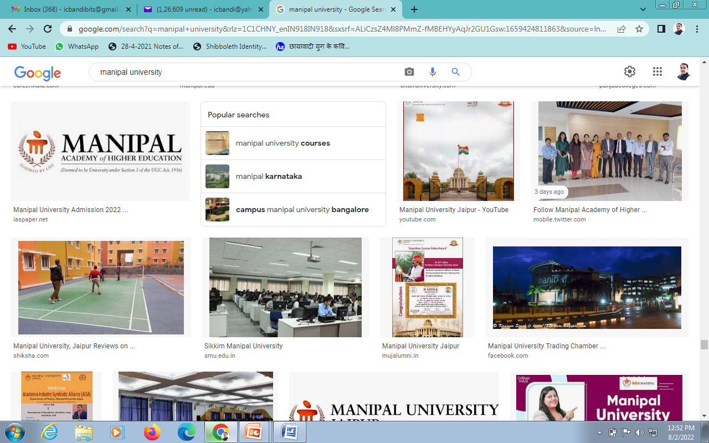

CENTRAL LIBRARY

Your
Photograph

LIBRARY MEMEBRSHIP FORM

The Chief Librarian
Central Library
Bengaluru Campus

This is to request you to kindly enroll me as a Member of ______________________ Library,
Bengaluru Campus. My personal particulars are given below:
MAHE ID No.
Name (in Block Letters)
Department | Department of
Category | UG/ PG/ Ph.D/Faculty/Visiting Faculty/  If any Other, Please Specify:
Date of Joining

Communication Address
Tel No.
Mobile No.
MAHE Email ID
Al
Alternate E-mail ID

I hereby agree to the following:

a. I promise to abide by all Library Rules, which may be made applicable from time-to-time.

b. I would be liable to pay any dues, in respect of damage/non return of Library books and fine payable for non-compliance of Library Rules and Regulations.

Signature of the Applicant: ……………………………………………………. Date: _______________________________________

(If Category is if any) Signature of the HOD : ………………………………………………………. Date: ______________________

Office Use
The Library Staff will create the patron account on our LMS

Name: _____________________________Signature:_________________ Date:_____________

Temporary Membership No. Assigned (if any):________________________________________

